Aws Ec-2 task

1: Launch one EC2 using Amazon Linux 2 image and add a script in user data to install Apache.
Ans: The very first step need to login to aws cloud and select ec2 service and click on lunch instance and select for advance settings and under the user data need to put coding to able to download the apache
(#!/bin/bash
sudo yum install httpd -y
echo “the apache is been downloaded”
systemctl start httpd) then click on lunch instance 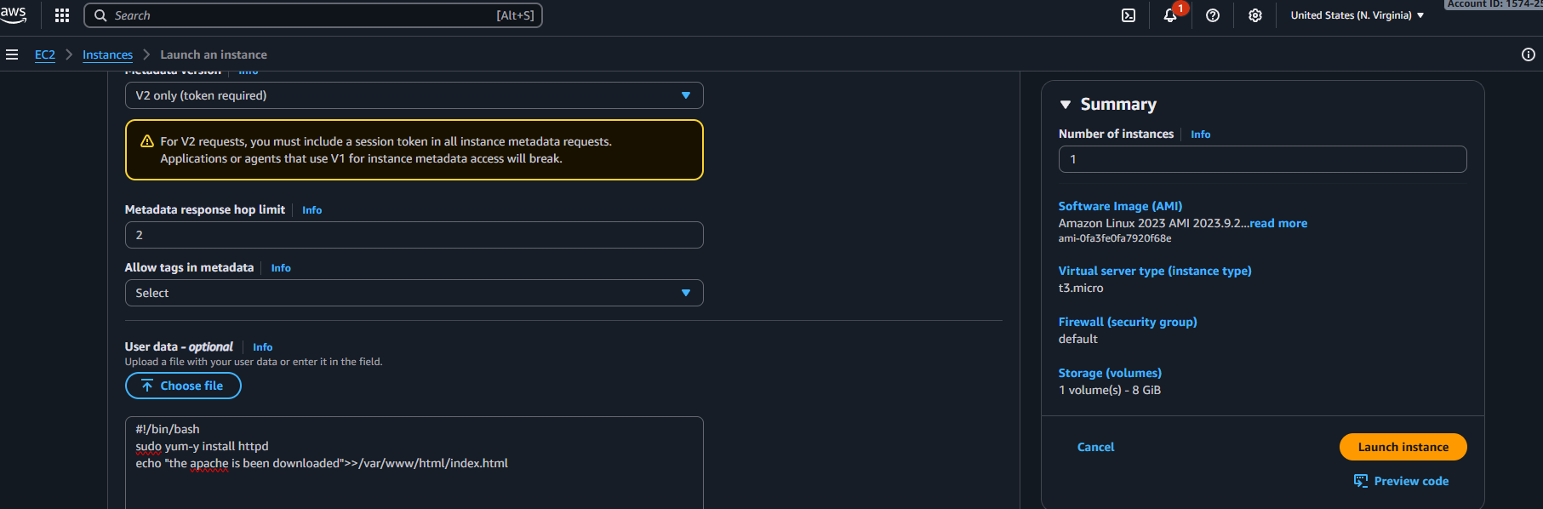
Then lunch the instance and open the gitbash and access remote server through the ssh key and check the status httpd
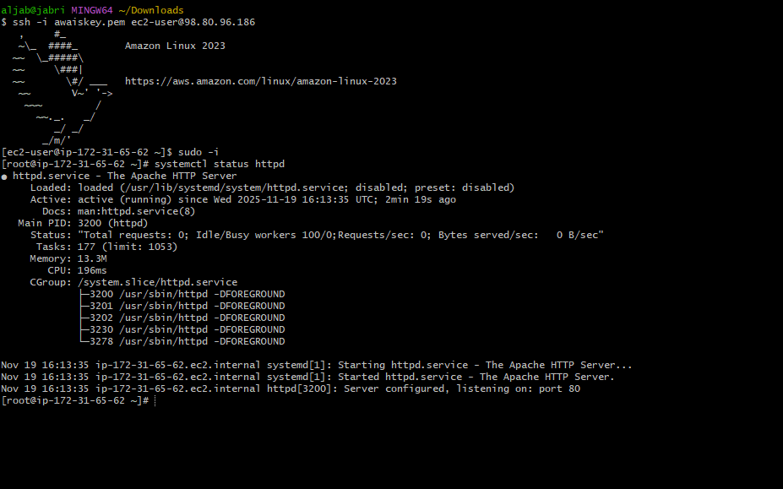
Then check the site through the public the ip and port 80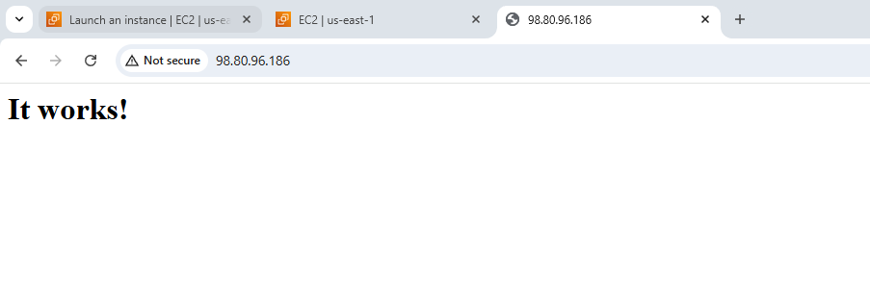

02: Launch one EC2 using Ubuntu image and add a script in user data to install Nginx.
Ans: First need to lunch the instance the ubuntu image in aws cloud add the script in user data
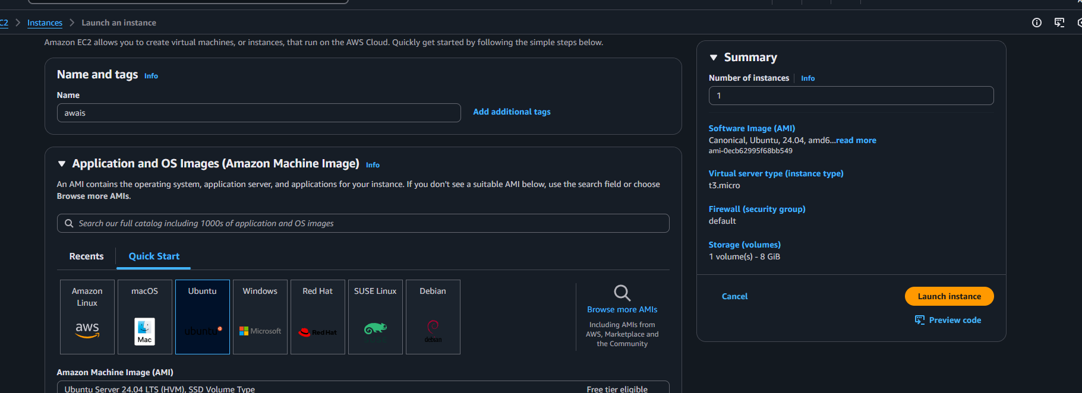
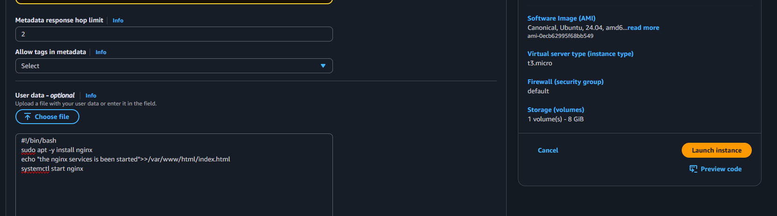Then need to lunch the instance and connect to remote server while connecting need to make sure use user name is ubuntu@publicip and once its been connected check the status 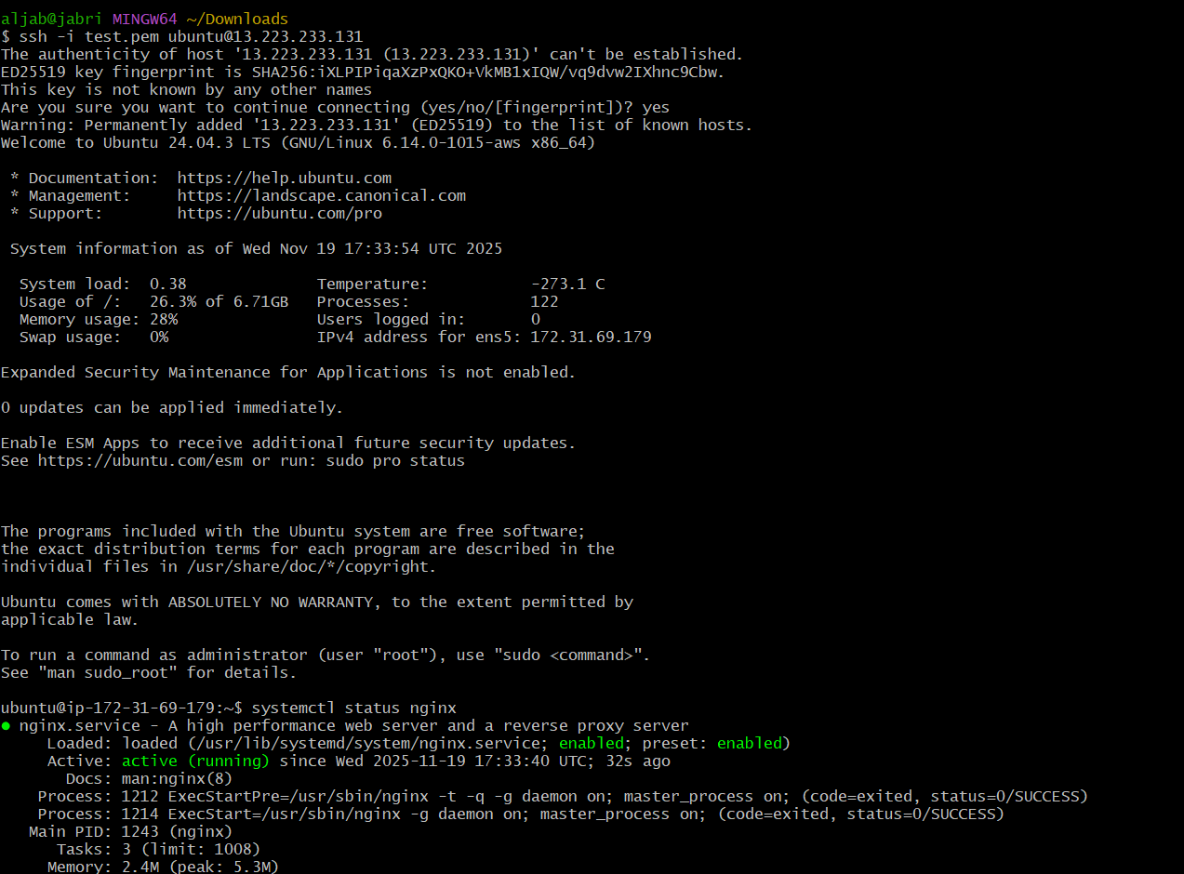
Check through the browser with public ip port no80
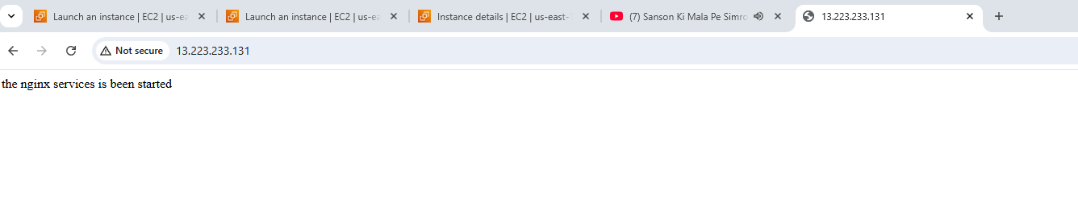

03: Launch one Windows server and install Tomcat on Windows.
Ans: Need to launch a instance by selecting the windows server and connect to server by uploading the password in RDI client and connect to server once its been selected need to install java and check the java version in powershell then need to install the tomcat and allow the path and restart the tomcat in service run in the browser by checking locahost with port no:8080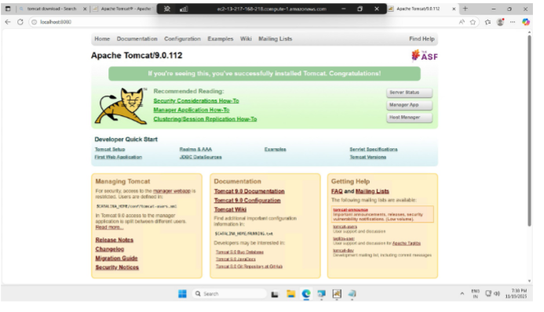

04: Take a snapshot of the instance created in Task 1.
Ans: Need to visit ec2 instances and select the instance which we want to take the snapshot then need to click on storage option and need to click on volume id under root device and create a snapshot add a name and description then check in EC2 snapshots
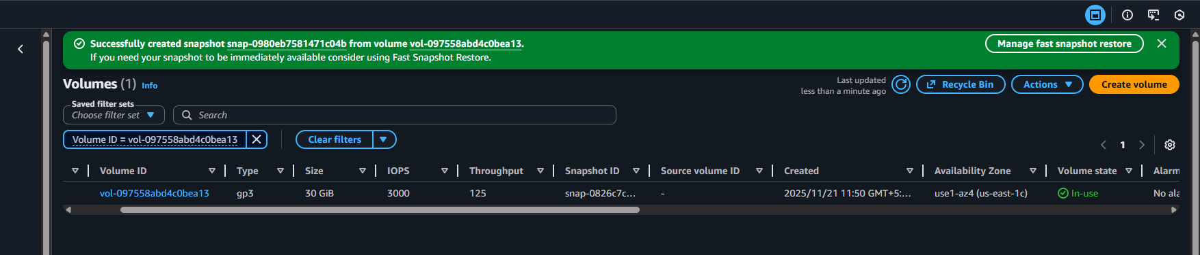

05: Assign passwordless authentication for the EC2 created in Task 2.
Ans: open git and run the command to generate the public key (ssh-keygen) copy the public key 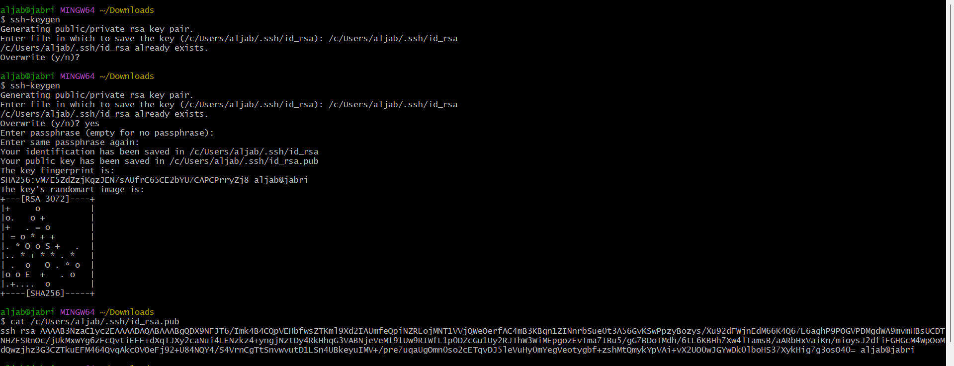 and access to remote server through the ssh command (ssh -I private key.pem ec2-user@public ip) 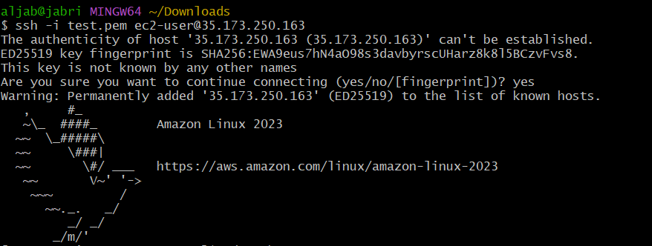
Then change the directory with .ssh(cd .ssh) then edit the authorized_keys and paste the public key save the file and exit the ssh remote and check by (ssh ec2-user@public ip)
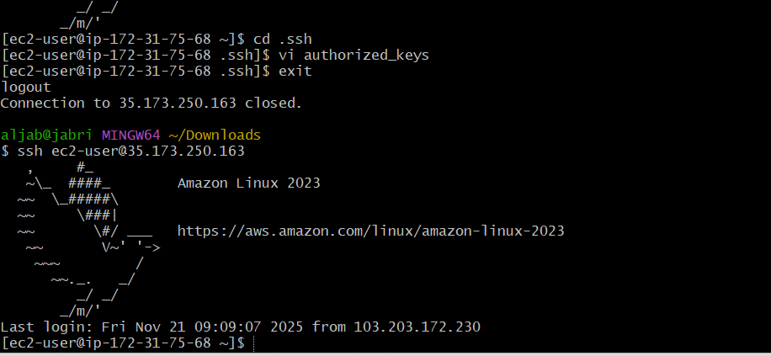

06: Launch any EC2 using the spot purchasing option.
Ans: login to aws consol click on ec2 lunch instance under the advance details there is purchasing option enable the option by clicking on spot instance then click set price need to entre the price per hour 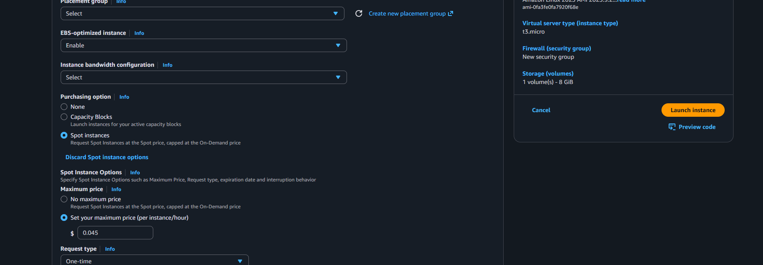

07: Enable termination policy on the EC2 created in Task 2.
Ans: To able to change termination policy select the instance click on actions under that there is a option termination policy click on it then enable the termination protection save it 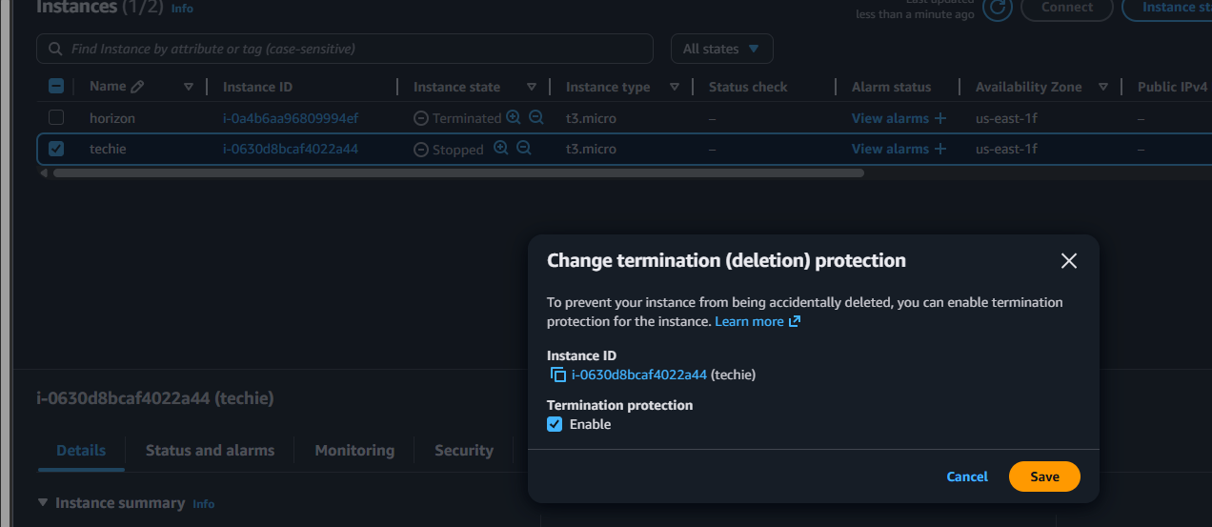

08: Launch one EC2 using AWS CLI.
Ans: first need to install the aws cli through chrome once it get downloaded create a key in iam service and open the git entre the command (aws configure) then need to enter the user name and password and then enter the server region and output 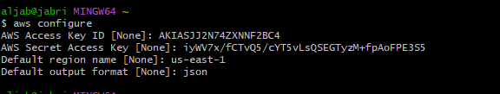

Now to able to lunch the instance need to enter the details
aws ec2 run-instances \
--image-id (instance ami) \
--instance-type (t3.micro) \
--key-name (MyKeyPair) \
--security-group-ids (details) \
--subnet-id (details) \
--count 1

I have enter (aws ec2 run-instances --image-id ami-0fa3fe0fa7920f68e --count 1 --instance-type t3.micro --key-name test --security-group-ids sg-0fb70ae4f079252db --subnet-id subnet-0c3cdb070ffda8fcb) to able to lunch instance 